ASSIGNMENT 2
FINAL LAB TASKS BY OM 2280156
COURSE CC

LAB 1

Microsoft Entra ID Overview
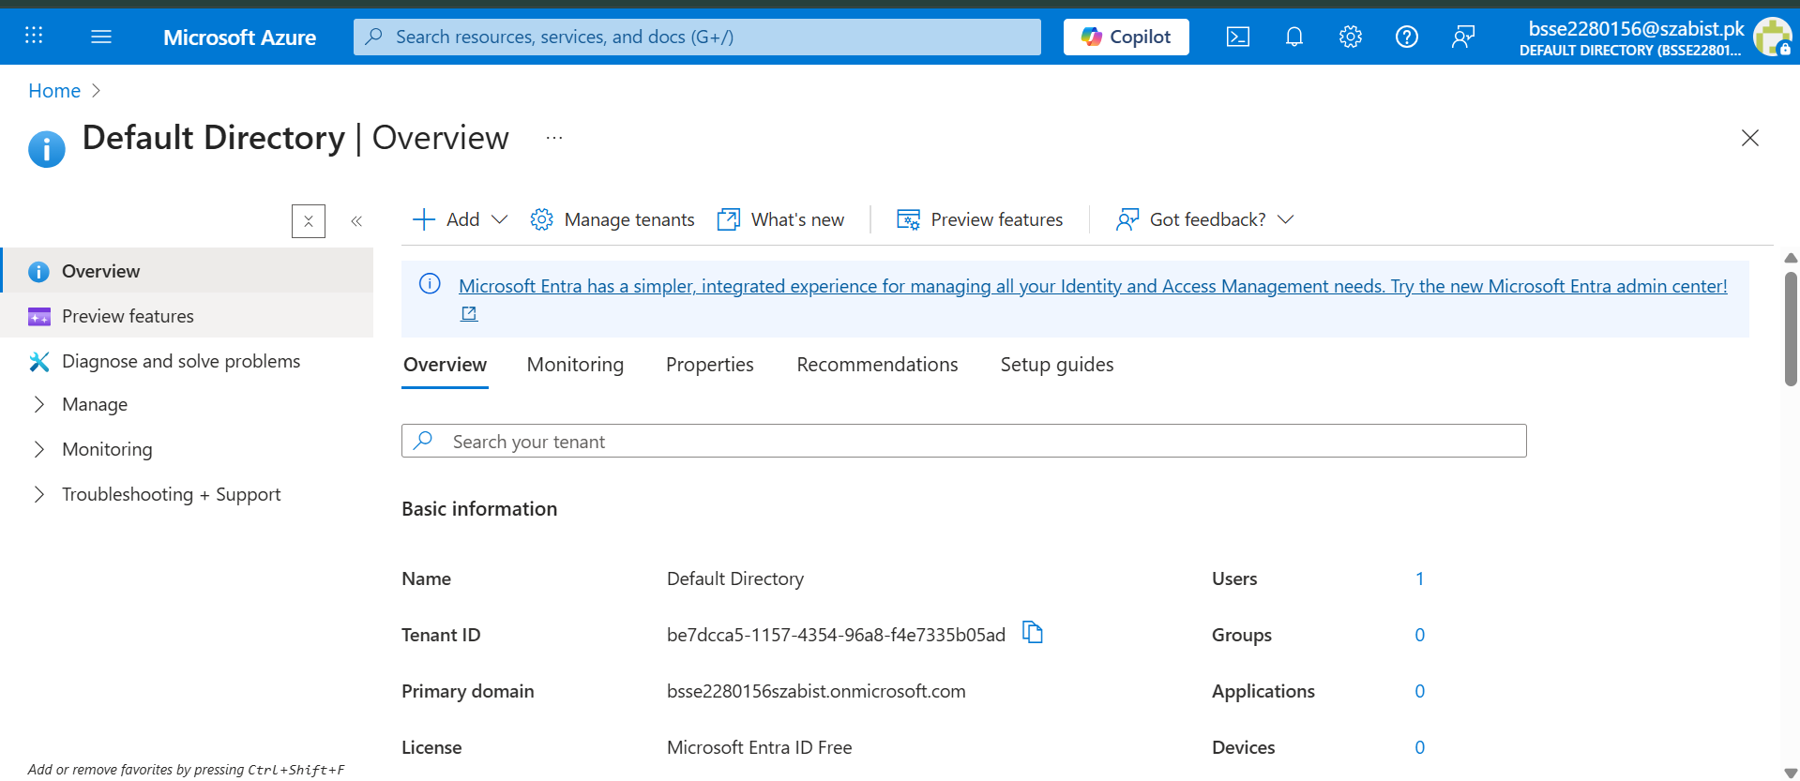

Creation of Internal Entra ID User
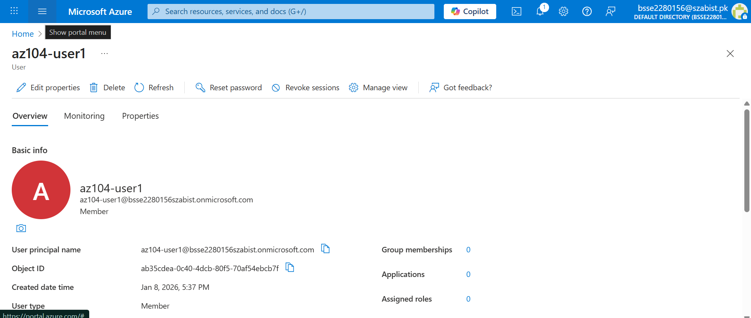

Invitation of External Guest User
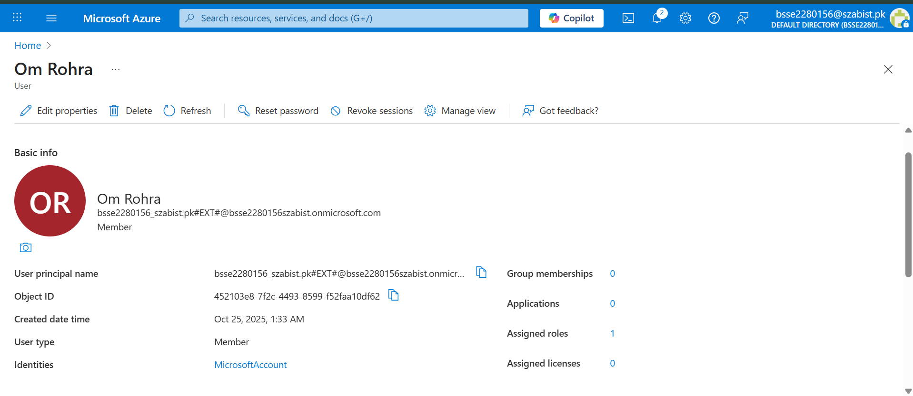

Users list showing Guest user
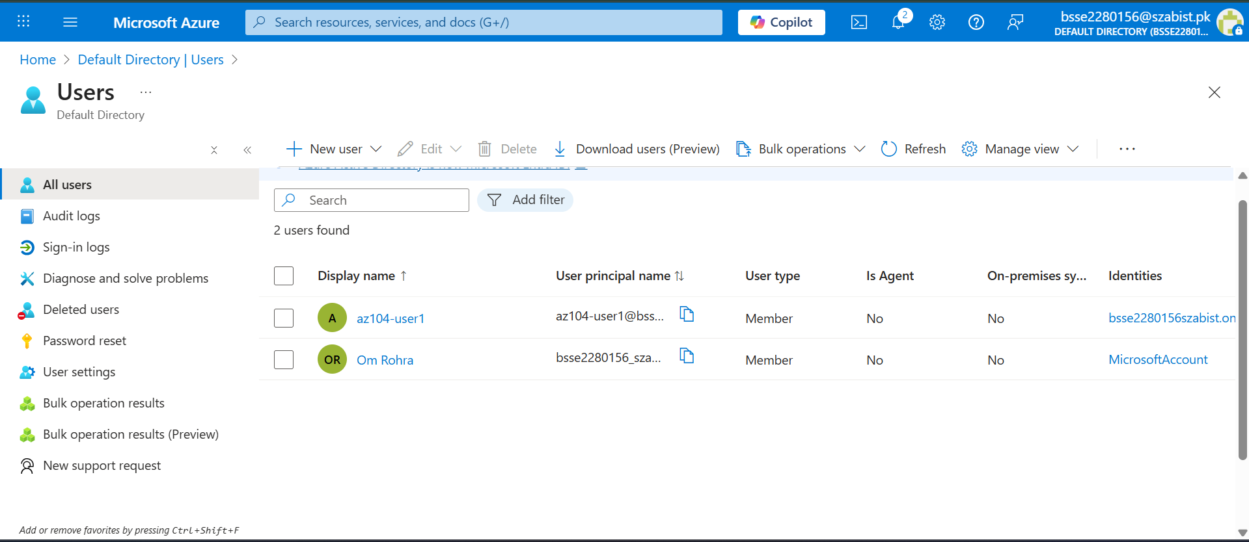

Creation of Security Group in Microsoft Entra ID
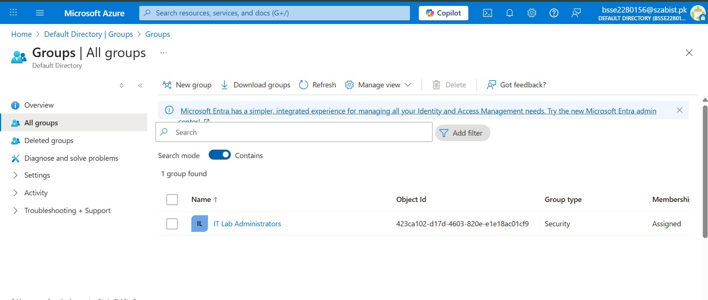
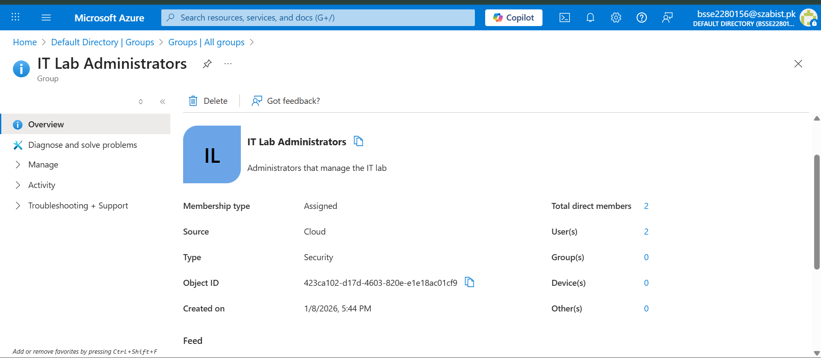

Security Group Members Assignment
